

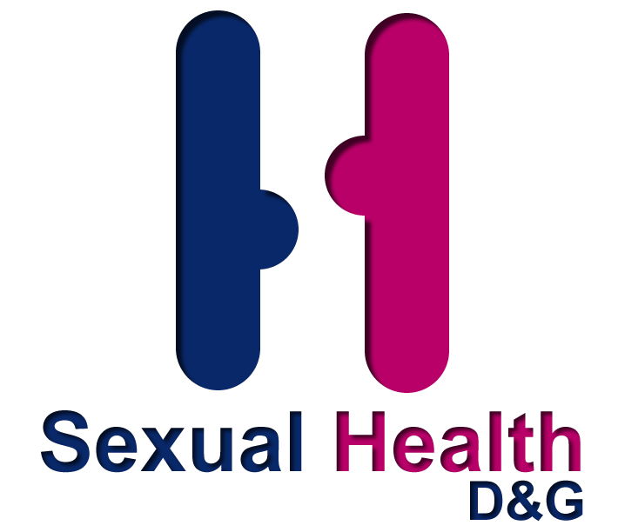




‘LETS TALK ABOUT SEX
101 ways to show someone you love them without having sex’
DUMFRIES & GALLOWAY’S SEXUAL HEALTH WEEK
25th – 31st January 2010

Why should we talk about sex?

We are surrounded with sexual images in our daily life.
Many young people feel under immense pressure to have sex.
It often feels as if everyone is having sex.
A happy and loving relationship between couples is an important part of positive sexual health and wellbeing.
We are being encouraged by the Scottish Government to ‘Talk about Sex’ in order to enhance our sexual relationships.

People of all ages from Dumfries & Galloway were asked for suggestions to show someone you loved them without having sex. 101 ways can be found at:
www.c4urself.org.uk

So What is Sexual Health?

Sexual health is a difficult concept to define and all too often sexual health is seen only in relation to negative physical outcomes such as unintended or unwanted pregnancies, sexually transmitted infections and the effects of abusive or coercive relationships. Sexual health is a complex sensitive issue influenced by culture, religion, economics and the wider structure of society.
The United Nations defines sexual health as "the integration of the somatic, emotional, intellectual and social aspects of sexual being, in ways that are positively enriching and that enhance personality, communication and love ... and thus the notion of sexual health implies a positive approach to human sexuality and the purpose of sexual health care should be the enhancement of life and personal relations and not merely counselling and care related to reproduction and sexually transmitted diseases."

AIM:

To encourage people to talk before entering a sexual relationship or to use words to enhance a current relationship.

RESOURCES AVAILABLE FROM DEPARTMENT:

DVD –‘Facing the Consequences’ – This DVD is about 2 young people who meet at a party and the consequences of too much alcohol. It raises the following issues: alcohol. Peer pressure, self esteem, relationships, risk taking behaviour, contraception and sexually transmitted infections. It is aimed at 3rd year secondary pupils and upwards and promotes the services available to young people.

DVD – ‘Deal With It’- This DVD follows 4 young people’s transition from primary school and through the first 2 years at secondary school. It looks at a variety of issues relating to growing up; bullying, peer pressure, alcohol and drug misuse, transition to secondary, self image, confidence, communication skills, parental expectations, friendship and making choices. ‘Deal With It’ highlights the importance of dealing with your problems. It is aimed at 1st year pupils.

Free Postal Testing Kits for Chlamydia (PTK’s) – The kits give people the option to be tested without attending a clinic or their Doctors, which can be difficult for many reasons in a rural area like Dumfries & Galloway. There are instructions with the kit and people are asked to provide a contact phone number so their results can be relayed to them. The kits fit into a standard post box and go straight to labs. The postage and the kit is free. The Dept will contact you by your chosen method of contact in 7-10 days to inform you of the results.

Posters: a range is available

Leaflets: a range is available

Condoms- a range is available and condom wallets
Website: www.c4urself.org.

Information on ‘Delay programme’
For Young people-designed by Jo Adams
Available to download at
www.c4urself.org.uk

DEPARTMENT CONTACTS:

Maggie Gurney Director of Sexual Health D&G
mgurney@nhs.net

Fiona Gleghorn Nurse Co-ordinator
fiona.gleghorn@nhs.net

Adele Hannah YP’s Sexual Health Co-ordinator
adele.hannah@nhs.net

Carol Louise Stewart
Health Improvement Programme Lead-Sexual Health
cstewart2@nhs.net

